
Bansilal Ramnath Agarwal Charitable Trusts'
Vishwakarma Institute of Technology, Pune - 37.
(An Autonomous Institute Affiliated to Savitribai Phule Pune University)
Department of Computer Engineering

SY OS Course Lab Assignment Submission:
College Name: Vishwakarma Institute Of Technology
Course Name: Operating System (OS)
Course Code: CS2310
Project Phase: Multiprogramming Operating System (MOS) - Phase 1 Simulation
Div: SY K
Branch: CS
Student Name: Siddesh Suresh Shirote
Roll Number: 27
PRN: 12412427
Date of Submission: 31/03/2026

Project Title:
Multiprogramming Operating System (MOS) Phase-1: Simulation of a basic operating system that executes one job at a time.
Aim
To simulate the basic functioning of an operating system (Phase-I) that executes one job at a time without multiprogramming, handling simple instruction execution, memory operations, and basic I/O using service interrupts.

Objectives: -
- To simulate the basic functioning of an operating system.
- To understand program loading and execution.
- To implement interrupt handling.
- To simulate memory operations.
- To perform basic input/output operations.

Theory: -
A Multiprogramming Operating System (MOS) allows multiple programs to reside in memory and execute by sharing CPU resources. However, in Phase 1 of this project, only one program is loaded and executed at a time. This phase focuses on understanding the foundational structure of an OS, including memory management, instruction execution, and interrupt handling.
1. Machine Specifications (The Virtual Machine): The system simulates a hypothetical computer with the following configuration:
- Memory: 100 memory locations (00 to 99), where each location stores one word (4 bytes).
- Registers:
  - IR (Instruction Register): 4 bytes, stores the currently executing instruction.
  - IC (Instruction Counter): 2 bytes, points to the next instruction.
  - R (General Purpose Register): 4 bytes, used for temporary storage.
  - C (Toggle): 1 byte, a Boolean condition flag ('T' or 'F') used for comparisons.
2. Instruction Format & Set: Each instruction consists of 4 characters (2 for Opcode, 2 for Operand address). For example, GD10 where GD is the opcode and 10 is the memory address.
- LR xx: Load register with memory value.
- SR xx: Store register value in memory.
- CR xx: Compare register with memory.
- BT xx: Branch if condition is true.
- GD xx: Read data into memory (block of 10 words).
- PD xx: Write data from memory to output (block of 10 words).
- H: Halt execution.
3. Interrupt System & Control Cards: The system uses a Service Interrupt (SI) to handle I/O in Master Mode: SI=1 (Read), SI=2 (Write), SI=3 (Terminate). Jobs are separated by control cards: $AMJ (Start of Job), $DTA (Start of Data), and $END (End of Job).

Algorithm / Execution Flow: -
- LOAD: Open the input file. Read lines sequentially. If $AMJ is found, initialize memory. Store subsequent program instruction blocks into memory starting at location 00.
- START EXECUTION: Upon reading the $DTA card, set the Instruction Counter (IC) to 00 and call EXECUTEUSERPROGRAM.
- EXECUTE USER PROGRAM (Fetch-Decode-Execute):
  - Fetch: Load instruction from memory into IR (IR = M[IC]).
  - Increment: Update IC to point to the next instruction (IC = IC + 1).
  - Decode: Read the first two bytes of IR to determine the operation.
  - Execute: Perform the required logic. If an I/O instruction (GD, PD, or H) is found, generate the respective SI interrupt and call MOS().
- MASTER MODE (MOS): Handle the interrupt based on the SI value.
  - READ (SI=1): Read the next data card from the input file and store 10 words into memory.
  - WRITE (SI=2): Fetch 10 words from memory and write them to the output file.
  - TERMINATE (SI=3): Append two blank lines to the output file to mark the end of the job.

Program: -
#include <stdio.h>
#include <string.h>

char M[100][4];
char IR[4];
char R[4];
int IC;
char C;
int SI;
int abortFlag;

FILE *fin;
FILE *fout;

void init() {
int i, j;
for (i = 0; i < 100; i++)
for (j = 0; j < 4; j++)
M[i][j] = ' ';

for (i = 0; i < 4; i++) {
IR[i] = ' ';
R[i] = ' ';
}

IC = 0;
C = 'F';
SI = 0;
abortFlag = 0;
}

int getAddress() {
return (IR[2] - '0') * 10 + (IR[3] - '0');
}

void MOS() {

if (SI == 1) {
char line[100];
int addr, k = 0, i, j;

if (fgets(line, sizeof(line), fin) == NULL) {
abortFlag = 1;
return;
}

line[strcspn(line, "\n")] = 0;

if (strncmp(line, "$END", 4) == 0) {
abortFlag = 1;
return;
}

int len = strlen(line);
while (len < 40)
line[len++] = ' ';
line[40] = '\0';

addr = getAddress();

for (i = 0; i < 10 && addr + i < 100; i++) {
for (j = 0; j < 4; j++) {
M[addr + i][j] = line[k++];
}
}
}

else if (SI == 2) {
int addr, i, j;

addr = getAddress();

for (i = 0; i < 10 && addr + i < 100; i++) {
for (j = 0; j < 4; j++) {
fputc(M[addr + i][j], fout);
}
}
fputc('\n', fout);
}

else if (SI == 3) {
fputc('\n', fout);
fputc('\n', fout);
}
}

void EXECUTEUSERPROGRAM() {
int addr, i;
char opcode[3];

while (1) {

if (IC < 0 || IC >= 100)
break;

for (i = 0; i < 4; i++)
IR[i] = M[IC][i];
IC++;

opcode[0] = IR[0];
opcode[1] = IR[1];
opcode[2] = '\0';

if (IR[0] == 'H') {
SI = 3;
MOS();
break;
}

addr = getAddress();

if (strcmp(opcode, "LR") == 0) {
for (i = 0; i < 4; i++)
R[i] = M[addr][i];
}

else if (strcmp(opcode, "SR") == 0) {
for (i = 0; i < 4; i++)
M[addr][i] = R[i];
}

else if (strcmp(opcode, "CR") == 0) {
int match = 1;
for (i = 0; i < 4; i++) {
if (R[i] != M[addr][i]) {
match = 0;
break;
}
}
C = match ? 'T' : 'F';
}

else if (strcmp(opcode, "BT") == 0) {
if (C == 'T')
IC = addr;
}

else if (strcmp(opcode, "GD") == 0) {
SI = 1;
MOS();
if (abortFlag) break;
}

else if (strcmp(opcode, "PD") == 0) {
SI = 2;
MOS();
}
}
}

void STARTEXECUTION() {
IC = 0;
EXECUTEUSERPROGRAM();
}

void LOAD() {

char line[100];
int m = 0;

fin = fopen("input.txt", "r");
fout = fopen("output.txt", "w");

if (!fin || !fout) {
printf("Error opening file!\n");
return;
}

while (fgets(line, sizeof(line), fin)) {

line[strcspn(line, "\n")] = 0;

if (strncmp(line, "$AMJ", 4) == 0) {
init();
m = 0;
}

else if (strncmp(line, "$DTA", 4) == 0) {
STARTEXECUTION();
}

else if (strncmp(line, "$END", 4) == 0) {
continue;
}

else {
int len = strlen(line);

while (len < 40)
line[len++] = ' ';
line[40] = '\0';

int k = 0;

for (int i = 0; i < 10 && m < 100; i++) {
for (int j = 0; j < 4; j++) {
M[m][j] = line[k++];
}
m++;
}
}
}

fclose(fin);
fclose(fout);
}

int main() {
LOAD();
printf("Execution Completed.\n");
return 0;
}
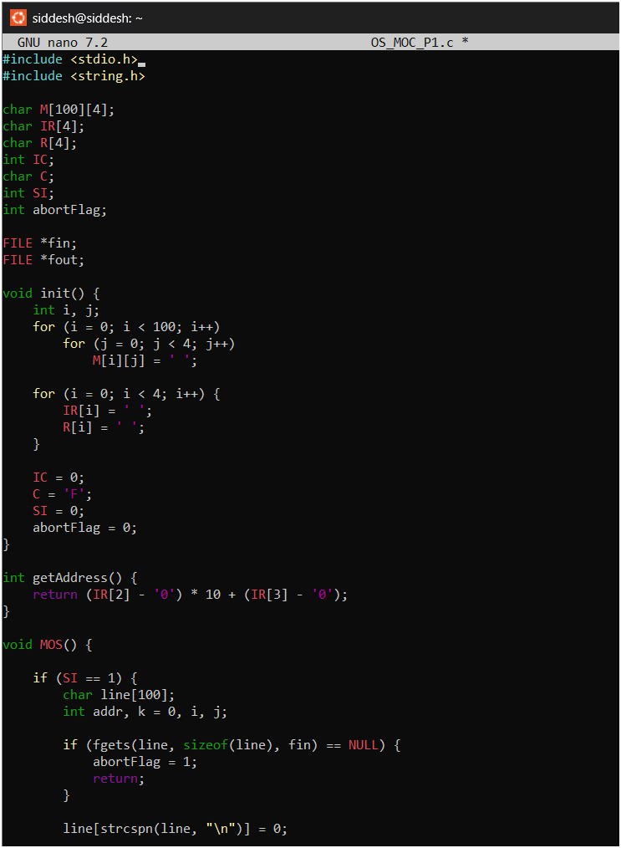
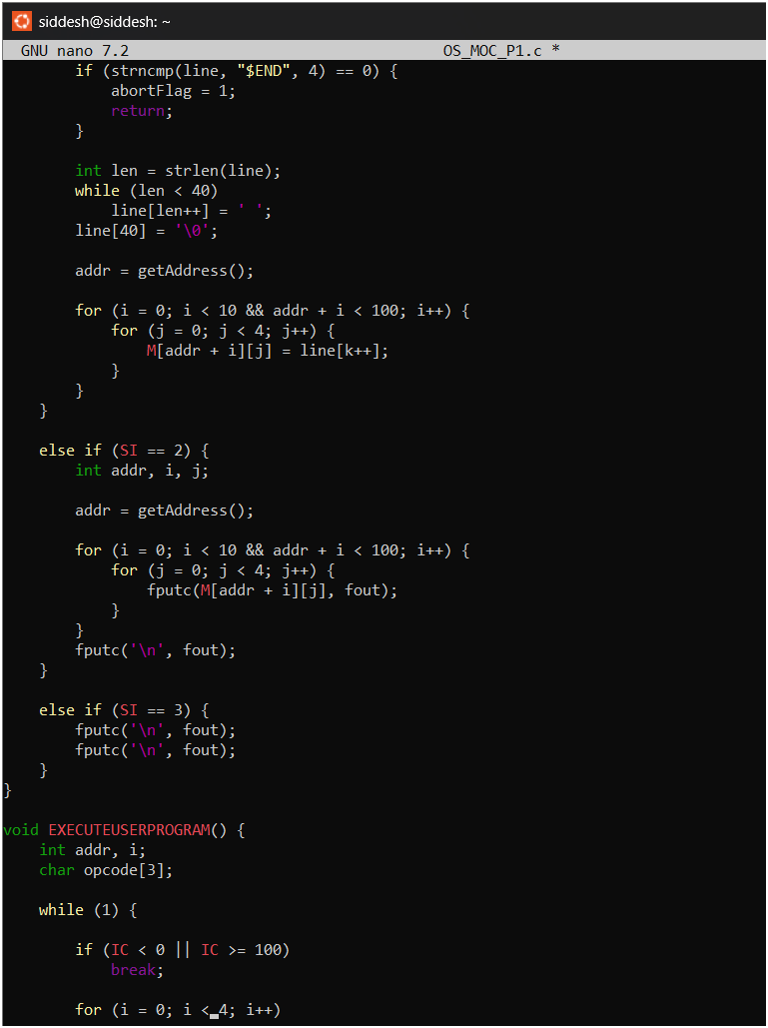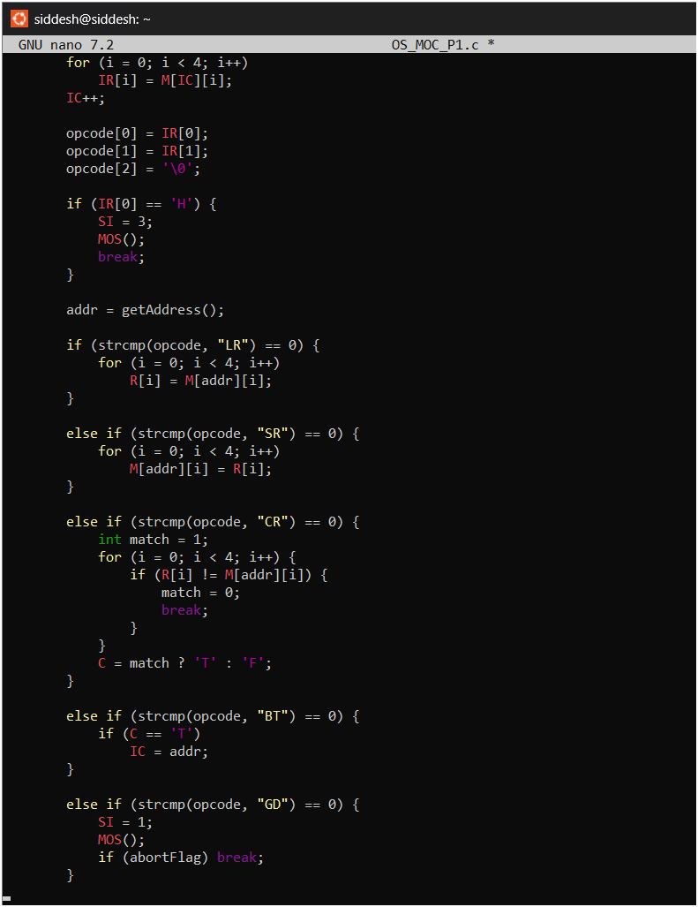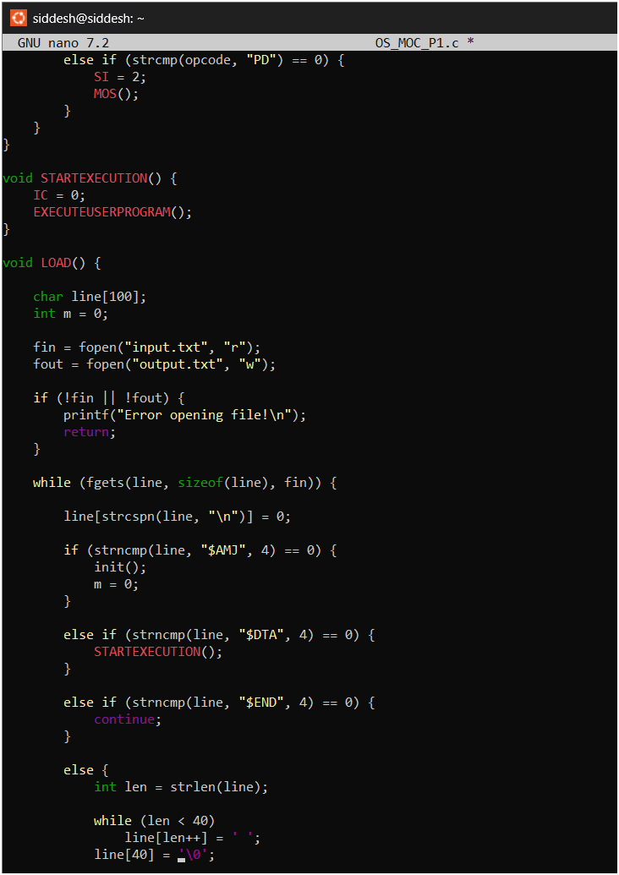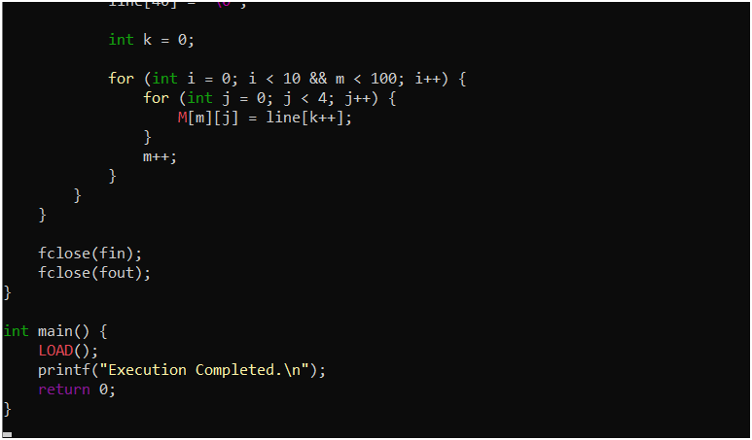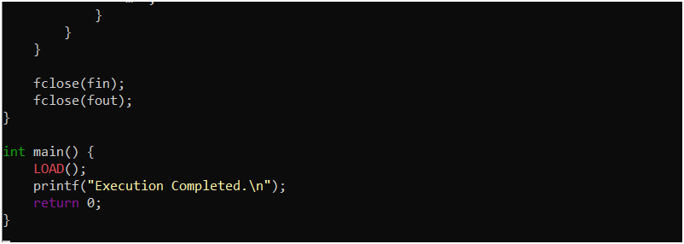
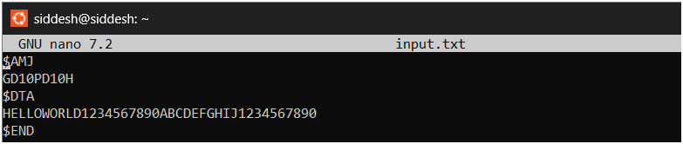
Output:-
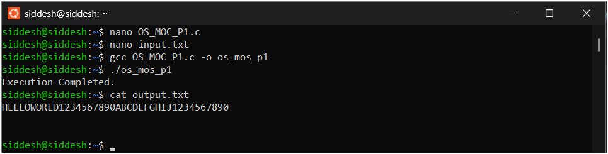

Conclusion:-
The MOS Phase-1 project successfully demonstrates the basic functioning of an operating system. By implementing this simulation, we understand how programs are loaded into memory, executed instruction by instruction via the fetch-decode-execute cycle, and how input/output operations are managed by triggering service interrupts in the Master Mode. Although it does not implement true multiprogramming, it establishes a strong foundation for understanding advanced OS concepts such as memory management and interrupt handling.

